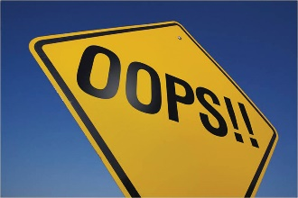
Types of Mathematical Errors

Careless Errors
- Writing the wrong number
- Not Following Directions
Computation Errors
- Adding, subtracting, multiplying or dividing incorrectly
Precision Errors
- Work too messy to understand
- Forget a negative sign
- Missing units
- Incorrect Notation
- Missing or incorrect label
Problem Solving Error
- Lack of understanding of the correct procedures
- Not following the correct procedures
- Failure to complete all the steps
- Not showing your work for all steps
- Not understanding what the problem is about

